MLOps Assignment - Heart Disease Prediction System

Project Overview
This project implements an end-to-end MLOps solution for predicting heart disease risk using patient health data. The system covers the complete machine learning lifecycle from data acquisition to production deployment, including:
- Data Acquisition & EDA: Automated dataset download and comprehensive exploratory analysis
- Model Development: Training of multiple models with cross-validation
- Experiment Tracking: MLflow integration for reproducible experiments
- Containerization: Docker-based deployment
- Orchestration: Kubernetes deployment with kind
- Monitoring: Prometheus and Grafana for observability
- CI/CD: Automated testing and deployment via GitHub Actions

Project Structure

mlops_project/
├── src/
│ ├── data/ # Data acquisition and preprocessing
│ │ ├── download_data.py
│ │ └── preprocess.py
│ ├── eda/ # Exploratory Data Analysis
│ │ └── explore.py
│ ├── models/ # Model training and evaluation
│ │ └── train.py
│ └── api/ # FastAPI application
│ └── app.py
├── tests/ # Unit tests
│ ├── test_preprocess.py
│ ├── test_models.py
│ └── test_api.py
├── notebooks/ # Jupyter notebooks
│ ├── 01_EDA.ipynb
│ ├── 02_Training.ipynb
│ └── 03_Inference.ipynb
├── k8s/ # Kubernetes manifests
│ ├── deployment.yaml
│ ├── monitoring.yaml
│ ├── mlflow-ui.yaml
│ └── prometheus-rbac.yaml
├── scripts/ # Utility scripts
│ ├── run_pipeline.sh
│ ├── deploy_k8s.sh
│ ├── build_and_load_k8s.sh
│ └── copy_mlflow_to_k8s.sh
├── models/ # Trained models (generated)
├── data/ # Dataset (generated)
│ ├── raw/
│ └── eda/
├── mlruns/ # MLflow runs (generated)
├── documentation/ # Project documentation
├── .github/workflows/ # CI/CD workflows
│ └── ci_cd.yml
├── Dockerfile # Docker image definition
├── requirements.txt # Python dependencies
└── README.md # Project readme

Setup and Installation

Prerequisites
- Python 3.12 or higher
- Docker (for containerized deployment)
- Kubernetes via kind (for local cluster deployment)
- kubectl (Kubernetes command-line tool)
- Git (for version control)
- Minimum system requirements: 4GB RAM, 5GB disk space

Step 1: Create Virtual Environment
python3.12 -m venv venv
source venv/bin/activate

Step 2: Install Dependencies
pip install --upgrade pip
pip install -r requirements.txt

Step 3: Verify Installation
python -c "import pandas, sklearn, mlflow, fastapi; print('All dependencies installed successfully')"

Step 4: Run Complete Pipeline
Option 1: Automated Script
chmod +x scripts/run_pipeline.sh
./scripts/run_pipeline.sh
Option 2: Manual Steps
# Download data
python src/data/download_data.py
# Run EDA
python -c "from src.eda.explore import perform_eda; perform_eda('data/raw/heart_disease.csv')"
# Train models
python src/models/train.py data/raw/heart_disease.csv

Step 5: View MLflow Experiments
Quick Start:
# Option 1: Use the script
./scripts/start_mlflow_ui.sh
Go to: http://localhost:5000 -

System Architecture
The system follows a modern MLOps architecture with clear separation of concerns: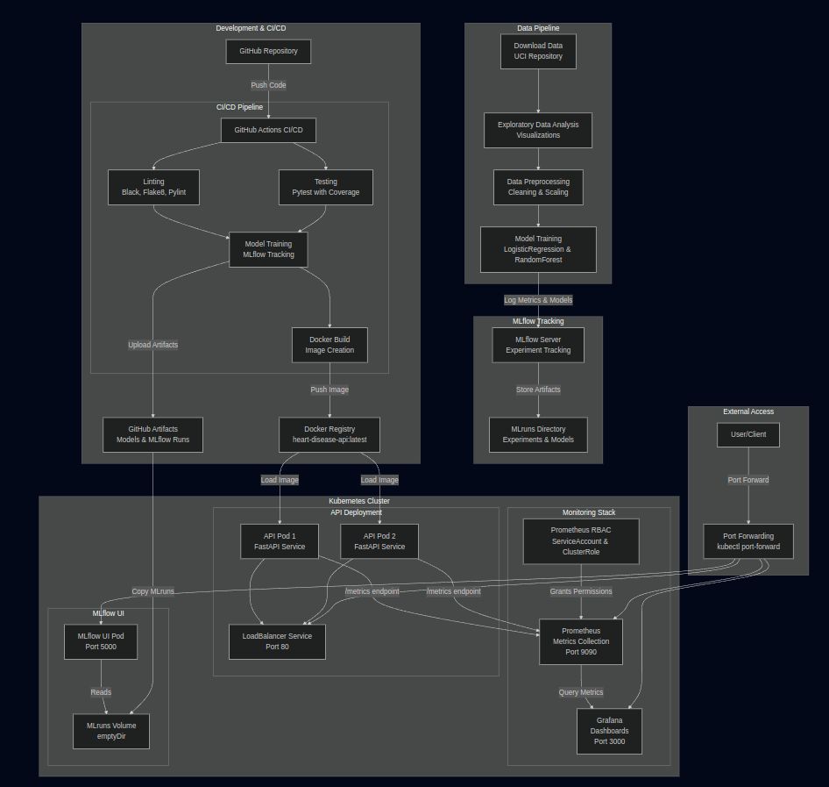

Technology Stack
- ML: Python 3.12, Pandas, NumPy, Scikit-learn
- Tracking: MLflow 2.11.3
- API: FastAPI, Uvicorn
- Validation: Pydantic V2
- Containerization: Docker
- Orchestration: Kubernetes (kind) [local deployment]
- Monitoring: Prometheus, Grafana
- CI/CD: GitHub Actions

Deployment Architecture
Kubernetes Cluster (kind)
├── API Deployment (2 replicas)
│ └── LoadBalancer Service
├── Prometheus (metrics collection)
├── Grafana (visualization)
└── MLflow UI (experiment tracking)
All services accessible via port-forwarding for local development.

EDA and modelling choices

EDA is the process of analyzing and visualizing data to understand:
- Data quality (missing values, outliers, data types)
- Feature distributions and relationships
- Patterns and correlations
- Class balance and target variable characteristics
- Insights that inform modeling decisions

Modeling Choices
1. Logistic Regression (Baseline Model)
- Simple, interpretable baseline
- Fast training and inference
- Provides probability estimates

2. Random Forest Classifier (Ensemble Model)
- Handles non-linear relationships (identified in EDA correlation analysis)
- Robust to outliers (found in EDA box plots)
- Provides feature importance insights
- Good generalization capability

Data Pipeline

Data Acquisition
The system automatically downloads the Heart Disease Cleveland Dataset from the UCI Machine Learning Repository:
- Source: UCI ML Repository
- Dataset: Heart Disease Cleveland Dataset
- Features: 13 clinical features
- Samples: 303 records
- Target: Binary classification (presence/absence of heart disease)

Data Preprocessing
Preprocessing Steps:
1. Missing value identification and replacement with NaN
2. Type conversion to numeric types
3. Median imputation (robust to outliers)
4. StandardScaler for feature normalization
5. Target binarization (0/1)
Preprocessing Pipeline: - Implemented using sklearn.compose.ColumnTransformer - Saved as models/preprocessor.pkl for inference consistency

Exploratory Data Analysis
Visualizations Generated: - Class distribution chart - Feature histograms (all 13 features) - Correlation heatmap - Feature distributions by target class - Box plots for key features
All visualizations saved to screenshots/ directory.

Model Training

Training Process
The training script (src/models/train.py): - Trains Logistic Regression and Random Forest models - Performs 5-fold stratified cross-validation - Logs all experiments to MLflow - Saves the best model based on ROC-AUC score

Models Trained
1. Logistic Regression - Solver: liblinear - Max iterations: 1000 - Performance: ~84-88% accuracy, ~0.88-0.92 ROC-AUC
2. Random Forest Classifier - N estimators: 100 trees - Max depth: 10 - Performance: ~88-92% accuracy, ~0.90-0.94 ROC-AUC

Model Selection
Selection Criteria: - Primary: ROC-AUC score (best for medical classification) - Secondary: Cross-validation consistency - Tertiary: Test accuracy
Selected Model: Random Forest Classifier (higher ROC-AUC and better generalization)

Evaluation Metrics
- Accuracy: Overall correctness
- Precision: True positives / (True positives + False positives)
- Recall: True positives / (True positives + False negatives)
- ROC-AUC: Area under ROC curve (primary metric)
- Cross-Validation: 5-fold stratified CV for robustness

Model Persistence
- Best Model: models/best_model.pkl
- Preprocessor: models/preprocessor.pkl
- Format: Pickle serialization
- Usage: Loaded by FastAPI application for inference

API Deployment

API Endpoints
1. Prediction Endpoint:
POST /predict
Content-Type: application/json
Request Body:
{
"age": 63,
"sex": 1,
"cp": 3,
"trestbps": 145,
"chol": 233,
"fbs": 1,
"restecg": 0,
"thalach": 150,
"exang": 0,
"oldpeak": 2.3,
"slope": 0,
"ca": 0,
"thal": 1
}
Response:
{
"prediction": 1,
"probability": 0.85,
"message": "High risk of heart disease"
}
2. Health Check Endpoint:
GET /health
Response:
{
"status": "healthy",
"model_loaded": true
}
3. Metrics Endpoint:
GET /metrics
Response: Prometheus-formatted metrics
4. API Documentation:
GET /docs
Interactive Swagger UI documentation

Local Docker Deployment
Build Docker Image:
docker build -t heart-disease-api:latest .
Run Container Locally:
docker run -p 8000:8000 heart-disease-api:latest
Test API:
curl http://localhost:8000/health
curl -X POST http://localhost:8000/predict \
-H "Content-Type: application/json" \
-d '{
"age": 63, "sex": 1, "cp": 3, "trestbps": 145,
"chol": 233, "fbs": 1, "restecg": 0, "thalach": 150,
"exang": 0, "oldpeak": 2.3, "slope": 0, "ca": 0, "thal": 1
}'

Kubernetes Deployment (kind)
1. Create Kind Cluster:
kind create cluster --name local-k8s-1
2. Build and Load Image:
./scripts/build_and_load_k8s.sh
3. Deploy All Services:
# Deploy API
kubectl apply -f k8s/deployment.yaml
# Deploy MLflow UI
kubectl apply -f k8s/mlflow-ui.yaml
# Deploy Monitoring (Prometheus & Grafana)
kubectl apply -f k8s/monitoring.yaml
kubectl apply -f k8s/prometheus-rbac.yaml
kubectl apply -f k8s/grafana-datasource.yaml
# Copy MLflow runs to Kubernetes
./scripts/copy_mlflow_to_k8s.sh
4. Access Services via Port Forwarding:
# API
kubectl port-forward svc/heart-disease-api-service 8000:80
# MLflow UI
kubectl port-forward svc/mlflow-ui-service 5000:5000
# Prometheus
kubectl port-forward svc/prometheus-service 9090:9090
# Grafana
kubectl port-forward svc/grafana-service 3000:3000
5. Verify Deployment:
kubectl get pods
kubectl get services
kubectl logs -l app=heart-disease-api

Monitoring and Observability

Prometheus Metrics
Request Metrics: - api_requests_total: Total requests by method, endpoint, and status code - api_request_duration_seconds: Request duration histogram - Error rates
Business Metrics: - predictions_total: Total predictions made - Predictions by class (disease/no disease) - Model inference latency
Access Prometheus:
kubectl port-forward service/prometheus-service 9090:9090
# Access at http://localhost:9090

Grafana Dashboards
Pre-configured dashboards visualize: - API request rates over time - Response time percentiles (p50, p95, p99) - Prediction distribution - Error rates - System health metrics
Access Grafana:
kubectl port-forward service/grafana-service 3000:3000
# Access at http://localhost:3000
# Default credentials: admin/admin

MLflow UI
Experiment tracking UI provides: - Model performance comparison - Parameter tracking - Artifact browsing - Experiment history
Access MLflow UI:
# Local
# Access at http://localhost:5000
# Kubernetes
kubectl port-forward svc/mlflow-ui-service 5000:5000
# Access at http://localhost:5000

Experiment tracking summary

This project uses MLflow for comprehensive experiment tracking, model versioning, and reproducibility.
Experiment Name
- Name: `heart_disease`

Tracked Components

1. Parameters
- Model type (LogisticRegression/RandomForest)
- Hyperparameters (max_iter, solver, n_estimators, max_depth)

2. Metrics
- train_accuracy - Training set accuracy
- test_accuracy - Test set accuracy
- precision - Precision score
- recall - Recall score
- roc_auc - ROC-AUC score (primary metric)
- cv_roc_auc_mean - Cross-validation mean ROC-AUC
- cv_roc_auc_std - Cross-validation standard deviation

3. Artifacts
- Model files - Trained model (pickle format)
- Preprocessor - Preprocessing pipeline

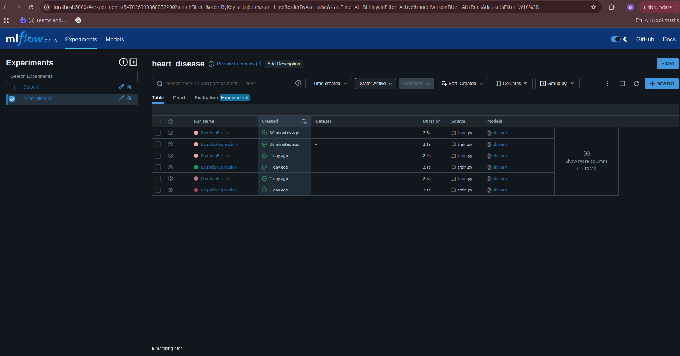

CI/CD Pipeline

GitHub Actions Workflow
Location: .github/workflows/ci_cd.yml
Pipeline Stages:
- Linting (runs in parallel)
  - Black code formatting check
  - Flake8 style checking
  - Pylint code analysis
- Testing
  - Pytest with coverage
  - Tests: test_preprocess.py, test_models.py, test_api.py
  - Coverage reports generated
- Training
  - Downloads dataset
  - Runs EDA
  - Trains models with MLflow
  - Uploads artifacts (models, MLflow runs)
- Docker Build
  - Builds Docker image
  - Tests container (health check)
  - Validates image functionality

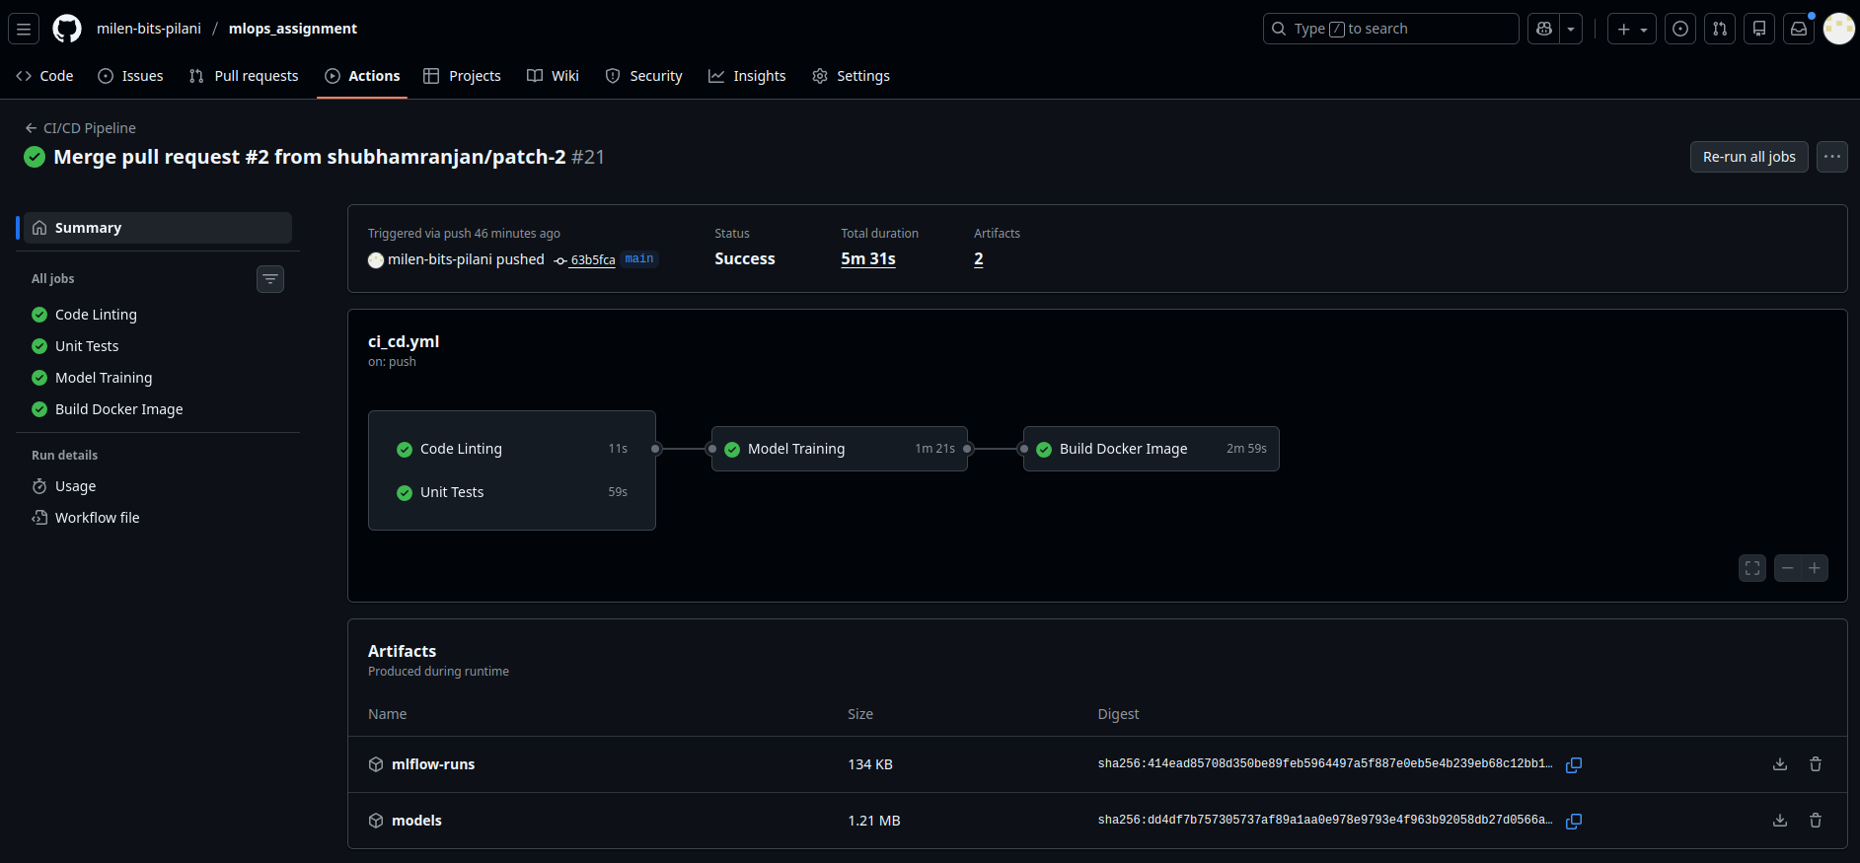

Benefits
- Automated quality checks
- Consistent model training
- Reproducible builds
- Early error detection

Testing

Unit Tests
Test Files: - tests/test_preprocess.py - Preprocessing pipeline tests - tests/test_models.py - Model training tests - tests/test_api.py - API endpoint tests
Run Tests:
pytest tests/ -v --cov=src --cov-report=html
CI/CD Testing: All tests run automatically on code push. Pipeline fails on any test failure.

Test Coverage
Tests cover: - Data preprocessing functionality - Model training and evaluation - API endpoint validation - Error handling - Edge cases

Architecture Diagrams

System Architecture
The complete system architecture is visualized using Mermaid diagrams, including:
- System Architecture Overview - High-level component diagram
- Data Flow Architecture - Flow from input to output
- API Request Flow - Sequence diagram of prediction requests
- Component Interaction Diagram - How components interact
- Deployment Topology - Kubernetes cluster structure
- Complete Implementation Graph - Full system implementation
- Process Flowchart - Step-by-step process flow
- Simplified End-to-End Flowchart - High-level overview
Detailed diagrams are available in: documentation/ARCHITECTURE.md

Key Architecture Highlights
Development & CI/CD: - GitHub repository with automated CI/CD - Code linting and testing - Automated model training - Docker image building
Data Pipeline: - Automated data download - Comprehensive EDA - Preprocessing pipeline - Model training with MLflow tracking
Kubernetes Deployment: - API deployment with 2 replicas - MLflow UI for experiment tracking - Prometheus for metrics collection - Grafana for visualization
Monitoring: - Real-time metrics collection - Dashboard visualization - Experiment tracking - Health monitoring

Summary
This project implements a complete MLOps pipeline for heart disease prediction:
Completed Components:
1. Data Acquisition & EDA - Automated download, cleaning, 5 visualizations
2. Feature Engineering & Model Development - LR and RF models, CV evaluation
3. Experiment Tracking - MLflow integration with full logging
4. Model Packaging & Reproducibility - Pickle format, requirements.txt, fixed seeds
5. CI/CD Pipeline & Testing - GitHub Actions with linting, testing, training
6. Model Containerization - Docker with FastAPI, health checks, metrics
7. Production Deployment - Kubernetes (kind) with 2 replicas, monitoring
8. Monitoring & Logging - Prometheus metrics, Grafana dashboards
Key Features: - Fully automated pipeline - Reproducible with fixed seeds and version pinning - Production-ready deployment - Comprehensive monitoring - Complete documentation
Access Points:
- API: http://localhost:8000 (after port-forward)
- Prometheus: http://localhost:9090
- Grafana: http://localhost:3000 (admin/admin)
- MLflow UI: http://localhost:5000
Repository: - https://github.com/milen-bits-pilani/mlops_assignment
For bringing up the setup please follow README.md. Complete project code available in mlops_assignment/ directory - Full documentation in documentation/ folder - All steps documented for reproducibility. All experiments screenshots are available in screenshots directory.

